Labs Proposal:
[Searching for a project name in cc google should yield no prior results. Prod.workload_insights table should not have mentions of the same project]
Please describe the project in one sentence and don’t spend more than one paragraph on it, so that it’s clear why it’s there and why we need to invest an effort in it.

Owners | @YOURNAME + @COMAINTAINER |  | Status | Design sketch
Product (team) | @PMNAME (TEAM) |  | Artifact | Library
Repository name | link |  | Language | Scala
Target release | YYYY-MM-DD |  | Go link | XXX
Please fill all of the fields before submitting a labs project. This document is a lightweight mix between http://go/designdoctemplate, http://go/prd, and a launch checklist. It is meant to make a more streamlined high-quality project for labs.
Review status 2
Part 1: Request for comments 2
Customer evidence 2
Markitecture 2
Graduation strategy 3
Project kickoff 3
Administrative actions 3
Part 2: Design sketch 4
[Optional] Major alternatives 4
Alternative: Buy from vendor Z 4
[Optional] Uncertainties and dependencies 4
Part 3: Launch checklist 5
API Clients 5
Notebook Libraries 5
Java/Scala projects 5
Python projects 5
Administration 5
Enablement 6
Continuous integration 6
Security & Legal 6
Longevity 6
Marketing 6

Review status
[Instructions]
Reviewer (team) | LGTM blockers [?] | LGTM | Updated
@Name (Labs) |  |  | YYYY-MM-DD
@Name (PM) |  |  | YYYY-MM-DD
@Name (Legal) |  |  | LPP-XXX
@Name (Security) |  |  | SDR-XXX
Stakeholders include someone that represents the customer(s) of this project and SMEs of any top-level architecture or processes that this project proposes changing.

Page: Everything You Need to Know About Security Design Reviews (SDRs) (go/sdr)
Page: SDR Process and Faqs | SDR FAQs

Part 1: Request for comments

Customer evidence
[We’re not publishing labs just for one customer. To publish a lab project, we need at least 10 customers who want it.]
- More than 10 customers want it right now

This project aims at XX% of our customers. Wanted by Customer A, because of B and would bring $XXXXXXX revenue.

Go-To-Market (GTM) Plan
[After a Labs project is published, there should be a GTM plan to grow the usage beyond those 10 customers. This may include one or more of the following:]
- Blog(s)
- Webinar(s)
- Present at conference(s)
- Present to partner(s)
- Publish to a 3rd party registry
- Develop and deploy a Sales Play
- Other
In order to

Markitecture
[Sell this architecture]
- Diagram is here

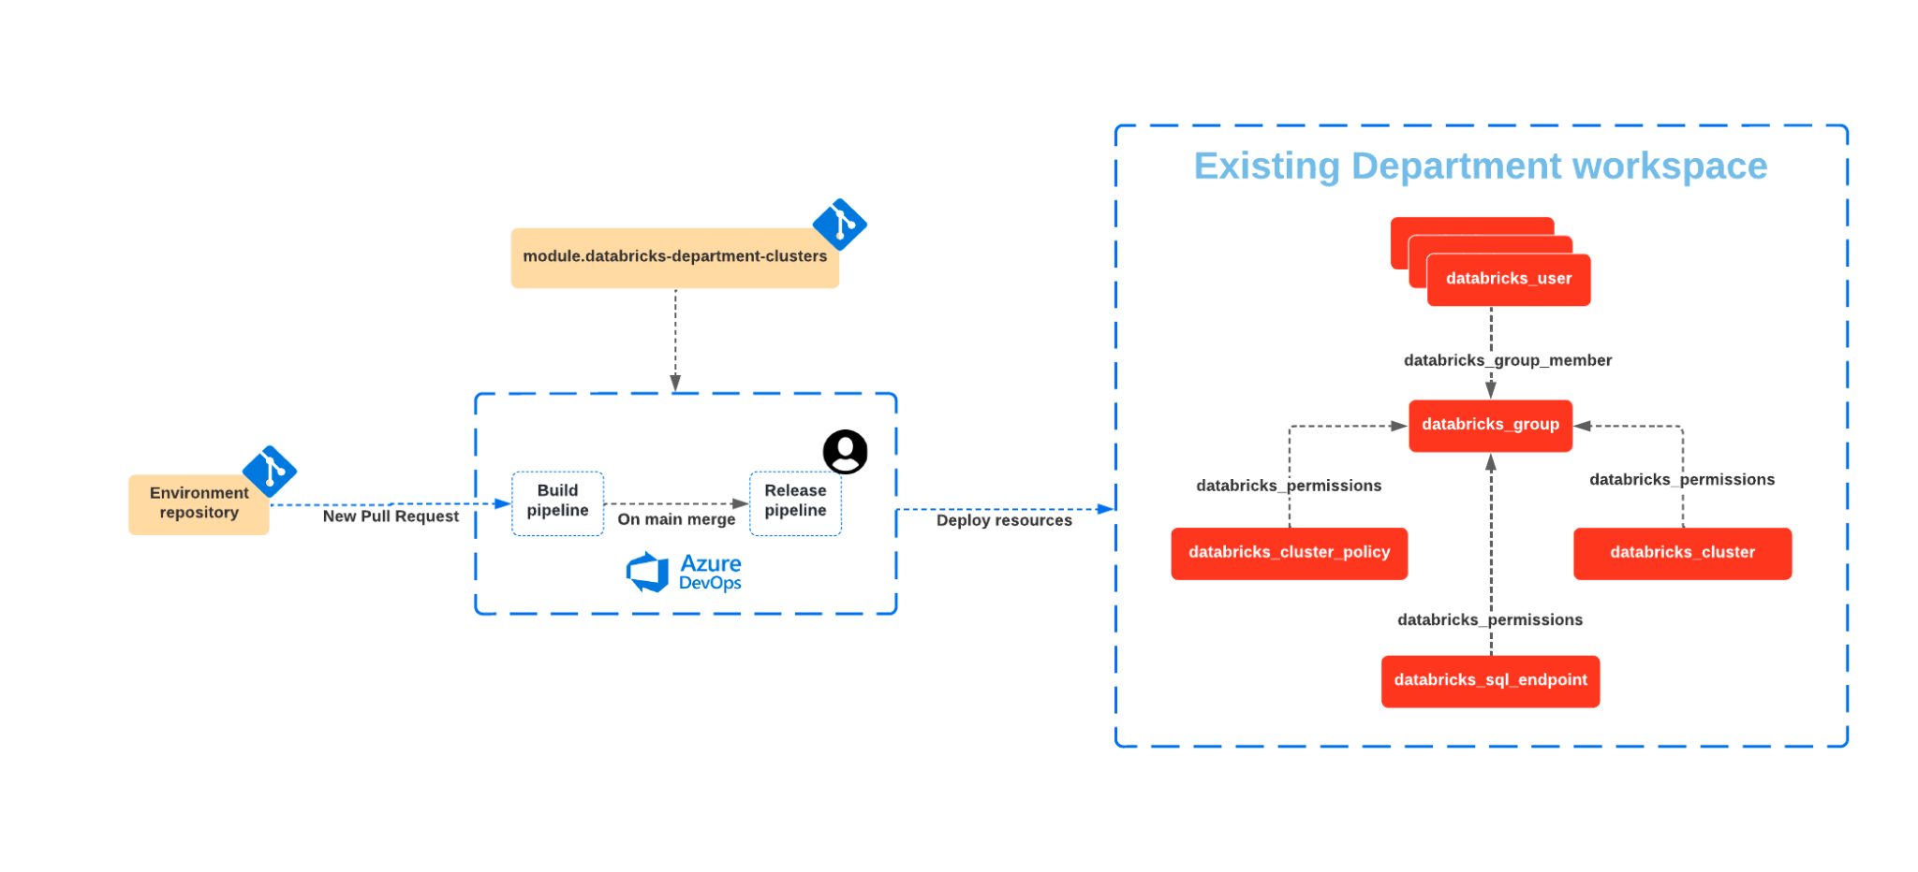

Graduation strategy
[All Labs should aim to be of high enough quality that it can easily be attached to the platform and provide a user experience that is indistinguishable from the features which are delivered by the product itself. Some of these projects may eventually make it into the product itself. One example - is the terraform provider, another example is dbx.

Please describe why this part of the product is missing and what gaps it fills. Mention the long-term strategy.]
- You are motivated to keep the project healthy in the long term. See http://go/labs/healthy for more details.
- At least one of the engineering teams could potentially take over this project into the main product
- At least one of the Product Managers support the idea of this project
- Labs guide and PM sign off on requirements and proposal

After discussions with Team X and Team Y (http://go/whoownsit), we think that it may land our ETL story very well.

Project kickoff
- Add your doc to the projects folder.
- Submit this doc to labs@databricks.com.

Administrative actions
These actions are performed by your Labs guide. Find one after PM and engineering counterparts sign off on the proposal. SLA is 2 weeks.
- Request labs-oss@databricks.com to create a repository in https://github.com/databrickslabs for the project.
- Request labs-oss@databricks.com to enable LABS_PYPI_TOKEN for a new repository.
- The project has a GitHub team added https://github.com/orgs/databrickslabs/teams
- Collaborators and teams: GitHub team has the Maintain rights on the project repository
- Collaborators and teams: Owner of the project has the ability to add more people to the project team
- Branches: The main branch has a protection rule
- Branches: The main branch requires a pull request before merging
- Branches: Restrict who can push to the main branch: Organization administrators, repository administrators, and users with the Maintain role (default)
- Tags: There’s tag protection rule for v*.
- Actions / General: Require PR approval for first-time contributors

Part 2: Design sketch
[Instructions]
- Labs reviewer and PM sign off on requirements and proposal
- Submit an SDR ticket for mandatory security and other reviews
- Required stakeholders sign-off on Design sketch

Many customers find Critical User Journey (CUJ) XYZ confusing, which limits its adoption (e.g., cited as a major pain point by customers A, B, C). This design reduces the steps to accomplish CUJ X by 50%, which we believe will improve the adoption of feature Y by 25%. See the Appendix for analysis.

[Instructions, you can use https://mermaid.live/ and markdown integration in GitHub to version control the diagrams, you can also use https://excalidraw.com/ to make lo-fi diagrams to copy into these documents]
We want to introduce a component to My System to support use cases A, B, and C.
My Service
Backend Service
Client Service
Cloud Storage
Database
This design
Existing component
?

[Optional] Major alternatives
[Instructions]

Alternative: Use OSS solution Y
There’s an OSS alternative that fits the same purpose, but our proposed solution is better in A, B, and C.

Alternative: Buy from vendor Z
We could offload the functionality to vendor Z instead of building it ourselves in My Service. Rejected because vendor Z can’t satisfy SHOULD requirements A and B. See vendor docs here.

[Optional] Uncertainties and dependencies
[Instructions]
- Azure API X can sustain 100 ops/sec
- Depends on completion of Team Y’s project Aha-XYZ

Project Tracking
How do you intend to track the usage of this project via our logfood telemetry?

There are various methods to track the usage of a Databricks Labs Project and attribute it to a number of DBUs. One or more of these can be employed. The preferred order is:
- Library Import Tracking
- Spark Config Parameter Tracking
- REST API tracking

Method | Description | Limitations
Library Import | Whenever a library is imported from a package, that telemetry is tracked against the cluster it was imported on. | DLT clusters do not track this for some reason (investigating)  DBSQL clusters cannot import libraries
Spark Config | Spark Configs can be tracked when used on clusters | Cannot be set via spark.conf.set(). Rather, it can only be detected if set upon cluster creation.  Cannot contain anything that is considered PII, like table name. Value is unable to be redacted.
REST API | Whenever a labs project is installed via the CLI, it’s name is included in the http_user_agent in the header. Other API calls to other Databricks endpoints can include the project name in the http_user_agent, along with other information, which can be detected. | Currently, the cluster_id is always redacted in the logs, which makes attributing labs projects to DBUs nearly impossible.  The lowest granularity therefore that can be attributed is to workspace.

Proposed Project Tracking
Track | Method | Description / Action Item | Action Taken
 | Library Import | Need to add library name to python_module_allowlist
 | Spark Config | Need to add spark config to spark config allowlist
 | REST API | Need to include project name in http_user_agent calls via the SDK method: databricks.sdk.config.with_user_agent_extra()

Part 3: Launch checklist

API Clients
[Please remove this section if the project is a library imported in a notebook]
- Unique user-agent string is designed for telemetry
- User-agent prefix is added to Labs ETL for telemetry

Notebook Libraries
[Please remove this section if the project is an API client]
- Package prefix is unique and didn’t appear in prod.workload_insights table
- Package prefix is added to Labs ETL for telemetry
- Check if the library does not exist in PyPI

Java/Scala projects
[Please remove this section if the project is written in Python]
- Maven is used as a build system (security scanning requirement)
- JaCoCo plugin is used
- Scalaguide is used (for Scala-projects)
- com.databricks.labs namespace is used

Python projects
[Please remove this section if the project is written in Java or Scala]
- There’s no project with a similar name on PyPI
- PyTest is used. See dbx or arcuate for examples.
- Setup.py has correct metadata. See arcuate for example.
- Style checks are enforced via black
- PyPI release is published
- PyPI release process is automated in CD, no manual release process is allowed
- Test coverage metrics are measured and presented publicly
- Reporting via codecov.io is required for http://go/labs/dash telemetry

Administration
[These actions are performed by Labs administrators]
- Dependabot is enabled
- (Python) LABS_PYPI_TOKEN added for this new repository
- Lgtm.io is integrated
- CodeQL checks are integrated

Enablement
[Please add enablement materials and link them to this section]
- Enablement deck is ready
- Enablement video pitch is ready
- Schedule internal enablement session

Continuous integration
[Testing is fully automated]
- Github Actions are invoked for every pull request
- Code coverage is greater than 80%
- Codecov.io is integrated

Security & Legal
- Submit an SDR ticket for mandatory security and other reviews
- Fill in http://go/designdoc/legal and submit LPP-XXX, follow up with legal-product@databricks.com

Longevity
Projects cannot reach the v1.0 version since it’s a labs project. To reach v1.0 means to get production-grade support and to be included in the main product. Project must always be http://go/labs/healthy:
- Code review is complete
- The release process is documented. See the arcuate.
- The release branch is locked to prevent force-pushes
- Initial release starts with v0.0.1 or v0.1.0
- End-user documentation is available. See datagen for example

Marketing
- Blog request is submitted - http://go/blogprocess
- Marketing request is submitted to add it to https://databricks.com/learn/labs

